GAME PLAYER USER GUIDE

REVISION 1.0
DATE CREATED 20/02/2017
LAST REVISION 20/02/2017
REVISED BY Brendan Broadhurst

Table of Contents

- Introduction Pg. 3
- How to install Pg. 3
- Adding games and videos Pg. 5
3.1 Adding games Pg. 5
3.2 Adding videos Pg. 6
- Changing the system settings file Pg. 7
- Hard coded buttons Pg. 9
- Credits Pg. 9
- Contact us Pg. 9

1. Introduction

This guide was made to assist users on how to use Game Player.

2. How to Install

To install Game Player you need to download it from the GitHub website:

https://github.com/enemwerribee/GamePlayer/releases

Make sure to Download the latest release.

You also need Microsoft Visual C++ 2015 (Vcredist), which can be downloaded here:

https://www.microsoft.com/en-us/download/details.aspx?id=53587

To check if you need the x64 or x86 version you need to find out if your computer is 64bit or 32bit.

To do this, open Control Panel and double click “System”. The window that comes up gives you basic information on your computer. The picture below shows what to look for:
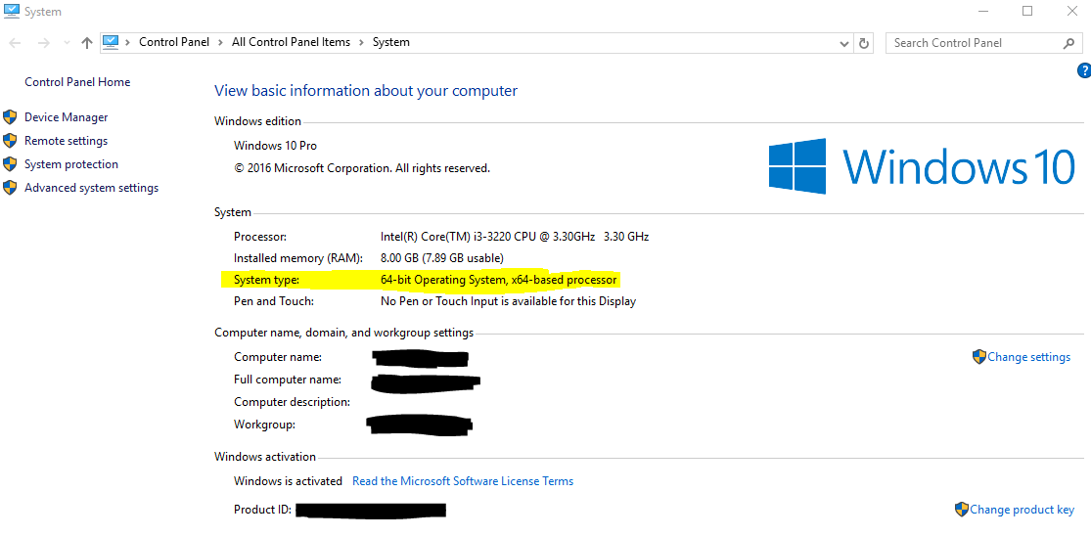

Once you have Game Player downloaded, copy it to any directory on your computer. As an example, we will use C:\GamePlayer as our install directory.
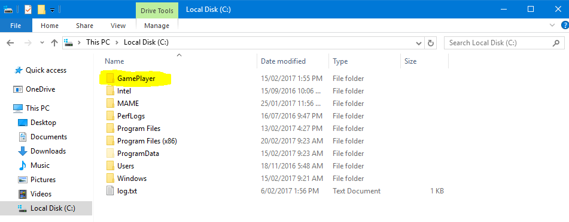

Now the you have installed the program you will want to install the Microsoft Visual C++ 2015 (VCredist) file that you downloaded and follow the install instructions on screen.

Returning to the GamePlayer file, open GamePlayer.exe. In doing so you should have the program launch.
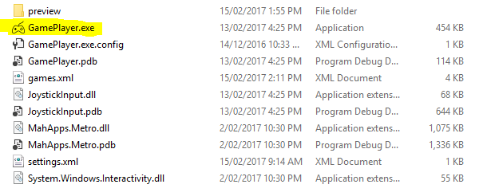

3. Adding Games & Videos

3.1 Adding Games

To add games you need to go to the install directory for Game Player.

Next you need to right click on the file games.xml
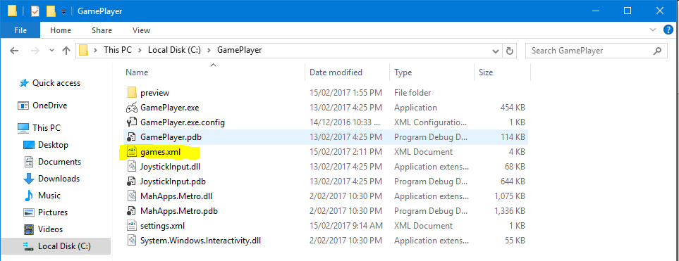

Right click, then edit.
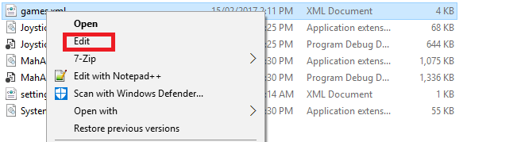

Once the file is open you should see something like this:
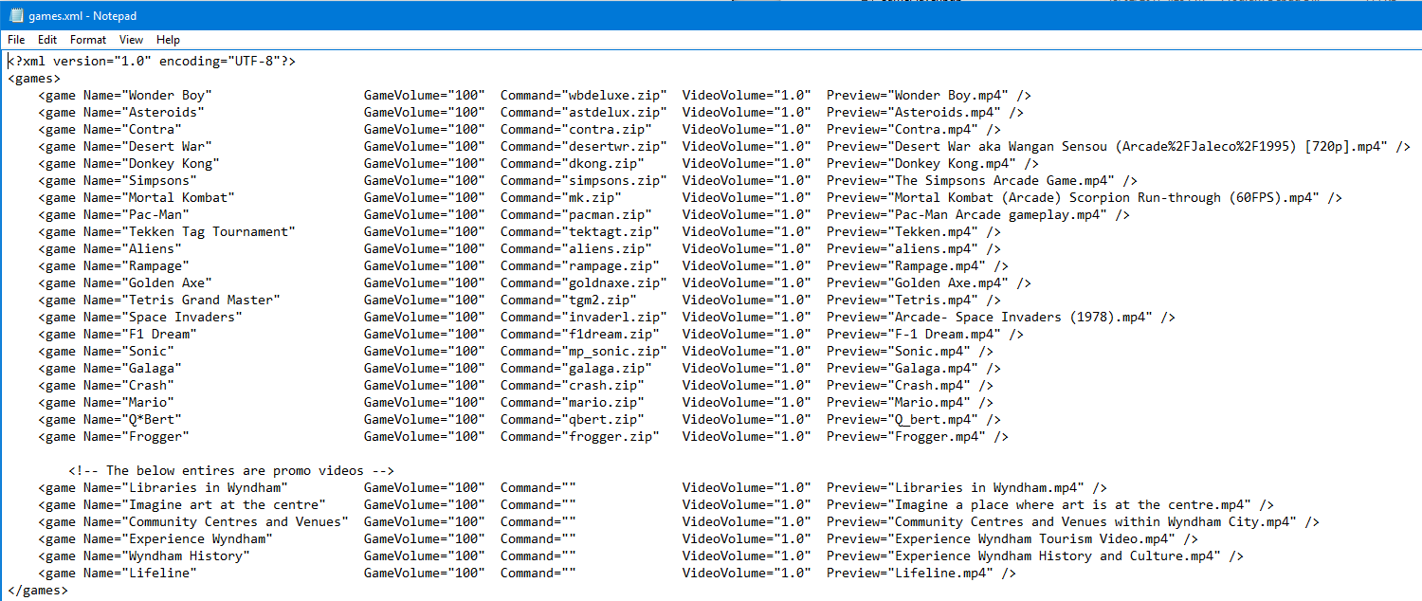

Now you need to add the information for your game or video. To do this you need the following line to be edited like below:

<game Name=“” Volume=“” Command=“” Preview=“” />

The line you add or edit needs to have a name. So if we were to add Frogger as one of the games in the program we would need to change; game Name=“” to game Name=“Frogger”

The next step is to change; Command=“” to Command=“frogger.zip”

Frogger.zip is the name of the game file that is being used to play the game.

Preview=“” needs to be changed to Preview=“frogger.mp4”

The preview format can be anything that plays in Windows Media Player (a video or music file).

The Volume=”” changes how loud a game is. If the game is naturally quiet, you’d use this to increase the volume. If there are no issues with volume, it is fine to leave it blank.

Once the line is edited it should look like this:

<game Name="Frogger" Volume="" Command="frogger.zip" Preview="Frogger.mp4" />

Now if you launch Game Player and open Frogger then the game will load.

If it doesn’t run, there’ll be an error message on screen that will inform you of why it failed to load. Generally this is because the file doesn’t contain all the necessary information for it to work.

To fix this, combine all the files for the game into one.

3.2 Adding Videos

<game Name="Example Video" Volume="" Command="" Preview="Example.mp4" />

The Volume command can be changed if the video is too loud. The Command field automatically plays the video, as the GamePlayer has this feature built in.

To add a video you need to do the following:

Change game Name=”” to game Name=”Example Video”

Change Preview=”” to Preview=”Example.mp4”

4. Changing System Settings File

To change the system setting file you need to navigate to your install directory, ie. C:\GamePlayer\
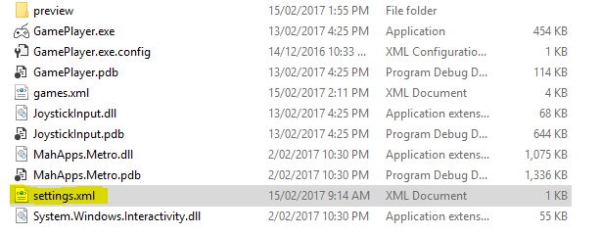

You then need to right click on settings.xml and select edit:
Once open you should see something like this:
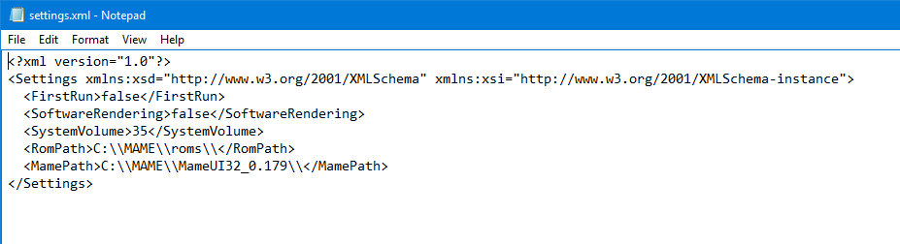
To set the ROM path we need to edit the following line:

<RomPath>C:\\MAME\\roms\\</RomPath>

So if you have your game files in a specific directory then you will need to change it to that directory.

It will need to be in the same format as above.
A normal directory path looks like this: c:\mame\roms\
But we need to change it to C:\\MAME\\roms\\ to make it work.

The next line to edit is the following:
<MamePath>C:\\MAME\\MameUI32_0.179\\</MamePath>

This is the directory you have installed mame in.

A quick way to get the directory is to hold SHIFT on your keyboard, then right click the folder for mame or the rom files. Then click Copy as path.
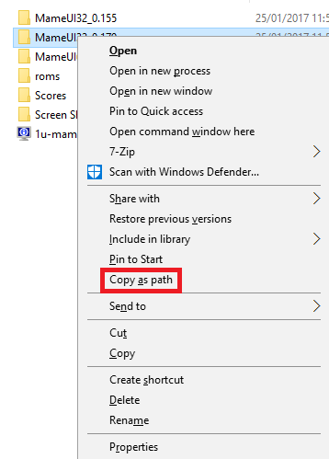

You will only need to edit the SystemVolume line if the whole system is too loud.

5. Hard Coded Buttons

There are some buttons that are hard coded into the program in order to allow for certain functions to be programmed in.

Button 10 on the control board will allow the launching and exiting of a game. This is symbolised by the yellow button on the screen.

Buttons 8 and 7 are hard coded to activate a service menu when both are pressed.

6. Credits

Game Player Creator: Steven G.
Lead Tester: Brendan Broadhurst
Project Manager: Joe Ferlazzo

7. Contact Us

If you have any suggestions, queries, or issues, please let us know via:

Github: https://github.com/enemwerribee/GamePlayer/issues
Email: Dmex@gmail.com

It is recommended that you use the github issue tracker first as it allows for other users to communicate with one another.

All suggestions for further development are appreciated and we strive to improve wherever possible.

